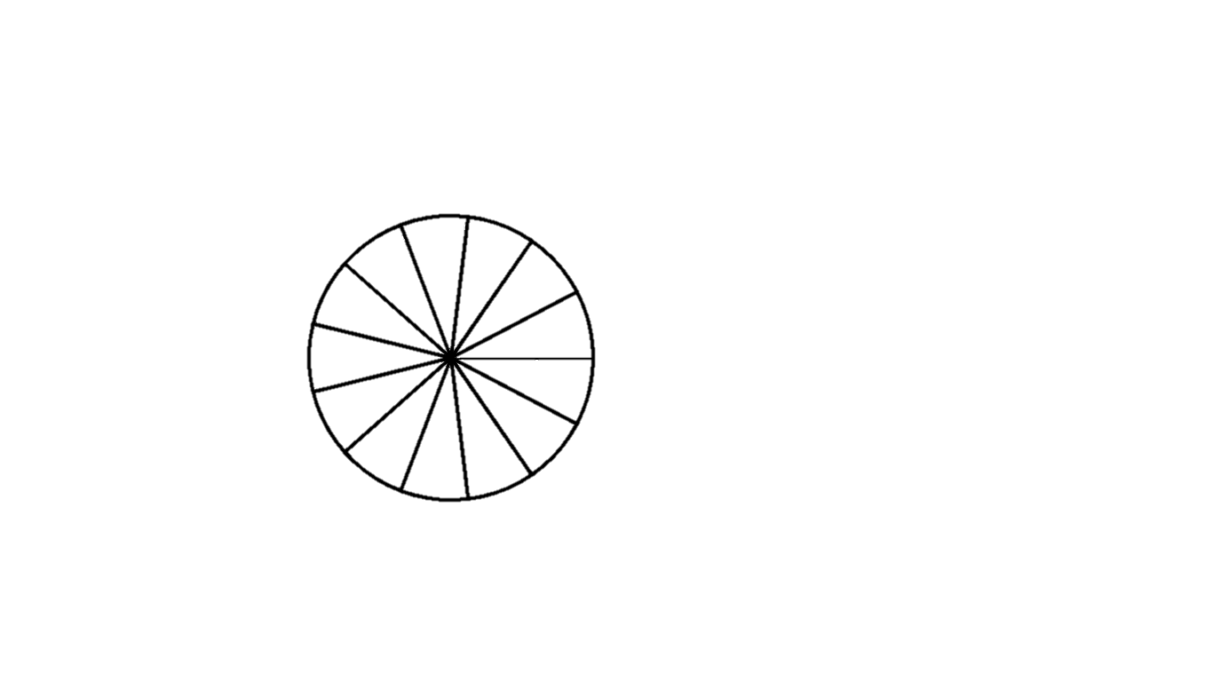

**Left and Right wheels correspond with Left and Right Controllers respectively.**

***To select a character, hover over the desired character and press the thumbstick down as a button.***

***Layer One --***

Maneuvering Right Thumbstick

Maneuvering Left Thumbstick

o

z

y

n

b

a

m

l

x

p

c

k

j

w

q

d

t

v

u

s

r

i

h

f

e

***Layer Two --***

Right Thumbstick

nN-zZ, 1-$, !-+

Left Thumbstick

aA-mM

g

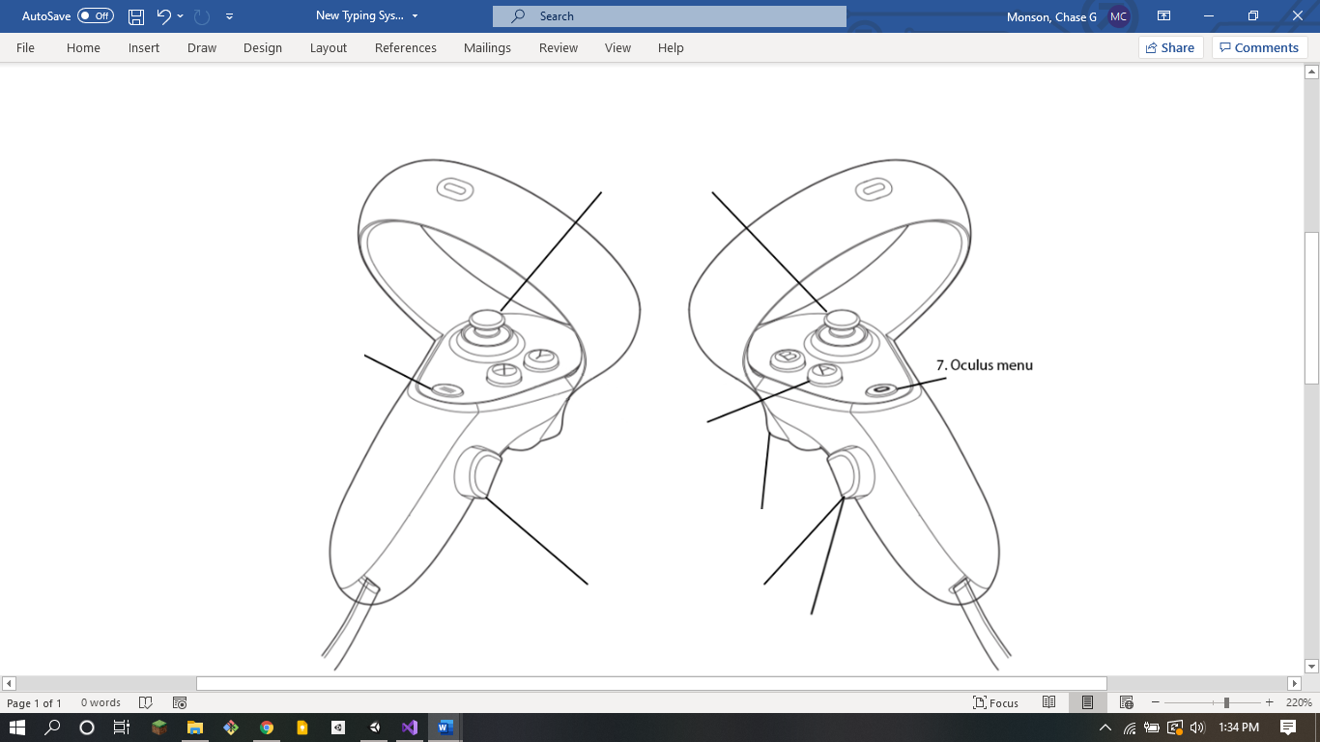

Maneuvering Right Thumbstick & B (shift) or A (CAPS)

Maneuvering Left Thumbstick & B (Shift) or A (CAPS)

A

M

N

Z

Y

O

L

B

X

P

K

C

Spawn Typing System, maybe?

W

Q

J

Oculus Menu, obviously

Shift

V

R

I

E

D

Special Characters

CAPS

S

T

U

H

G

F

***Layer Three – Null for Right Controller***

R

L

Cancel

Enter

Numbers

Maneuvering Right Thumbstick & X (Numbers)

$

,

1

Backspace

Space

.

2

0

3

9

4

8

7

6

5

***Layer Four -- Null for Right Controller***

Maneuvering Right Thumbstick & Y (Special Characters)



+

-

?

!

@

*

/

#

_

)

(

=

%